6. Variogram:
The variogram is defined as the variance of an increment, it certainly has to fulfil several conditions which will be discussed in the section describing the theoretical variograms. Naturally there are also properties of the variogram which we know or suppose without any precise mathematical description.
1. From the definition we have γ(0) = 0 .
2. From the definition γ(h) ≥ 0 for all h vectors.
3. From the definition γ(h) = γ(−h) for all h vectors.
4. In most cases we suppose there is some kind of continuity in the parameter we are dealing with. This means that the variance of the increments is supposed to increase with the length of the vector h.
5. In several cases there is a certain limit in the continuity of the parameter. This means that if the vector separating two points exceeds a certain limit the variance of the increment will not increase any more.
6. The variogram is often discontinuous near the origin. This means that for any h ≠ 0 we have γ(h) ≥ C(0) > 0. This phenomenon is the so-called nugget effect. The nugget effect can partly be explained by the measurement error and partly by a random component in the parameter which is not spatially dependent.
It is clear that the hypothesis about the existence of the variogram is the key point of geostatistics. The first question naturally arising is: Can we assume that our parameter under study fulfils the intrinsic stationarity?
Suppose that measurements of the parameter are taken at locations x_{i} for i = 1, . . . ,n. Let Z(x_{i}) be the measured values.
As a first step is to calculate the values ( Z(x_{i})−Z(x_{j}) )² for all the pairs formed from the measurement points x_{i}, and would then plot them with respect to the distance separating the points (and perhaps direction). This way a so called variogram cloud is obtained. Figure 2 shows such a variogram cloud. It seems to be a rather discouraging result.
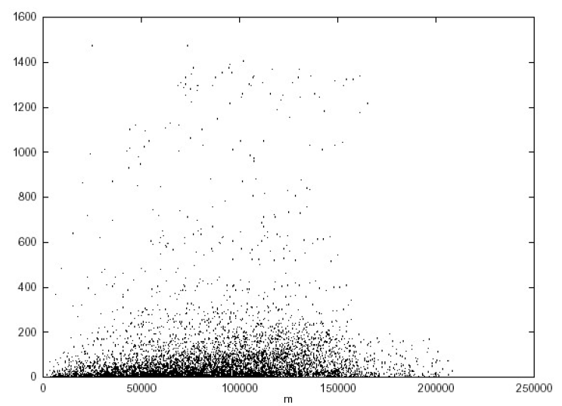

Figure 2: Variogram cloud [mm²].

However, the condition shown in eq.6 did not promise that for all possible pairs the value of ( Z(x_{i})−Z(x_{j}) )² will be close to a certain line. It is a statement on the expectation of these values. If we draw these expectations (calculated as arithmetic means) for the same case as for which the variogram cloud was obtained (figure 2) the result is already promising as shown on figure 3.

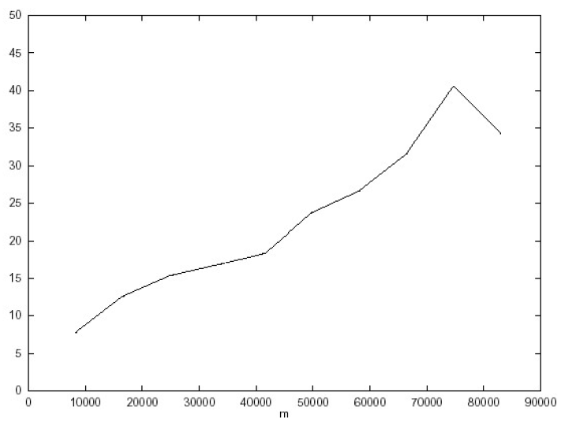
Figure 3: Experimental variogram [mm²].

6. The Experimental Variogram:
The first step in turning theory into practice is to estimate the variogram from
sample data, say z(x₁), z(x₂),…, where x₁, x₂,… denote the positions of the sample in two-dimensional space. We assume that those positions have been selected without bias. They need not be random, as in design-based estimation, because we treat the variables as the outcomes of random processes. Therefore, we can take a relaxed attitude to the sampling design, which may be systematic, random, nested or some combination.
The usual equation to compute the variogram is Matheron’s method of moments (MOM) estimator as following:

$\hat{γ}\left(h\right)=\frac{1}{2N(h)}\sum_{i=1}^{N(h)}{{\{z\left(x_{i}\right)-z\left(x_{i}+h\right)\}}^{2}}$ … 8

where $z\left(x_{i}\right)$ and $z\left(x_{i}+h\right)$ are the observed values of z at places x_{i} and x_{i} + h, and N(h) is the number of paired comparisons at lag h. By changing h we obtain an ordered set of semi variances; these constitute the experimental or sample variogram. The way that Eq. (8) is implemented as an algorithm depends on whether the data are regularly spaced in one dimension, are on a regular grid or are irregularly distributed in two dimensions.

Example 1:
Suppose we have the following measurement points and these measurement points are aligned along the same straight line. (For example data of the same borehole.) Also suppose that all the data points are equally spaced – two neighboring data points are separated by the distance of 1 meter.

x | 1 | 2 | 3 | 4 | 5 | 6 | 7 | 8 | 9 | 10
Z(x) | 41.2 | 40.2 | 39.7 | 39.2 | 40.1 | 38.3 | 39.1 | 40.0 | 41.1 | 40.3

$$γ\left(1\right)=\frac{1}{18}[ {\left(41.2-40.2\right)}^{2}+{\left(40.2-39.7\right)}^{2}+{\left(39.7-39.2\right)}^{2}+{\left(39.2-40.1\right)}^{2}+{\left(40.1-38.3\right)}^{2}+{\left(38.3-39.1\right)}^{2}+{\left(39.1-40.0\right)}^{2}+{\left(40.0-41.1\right)}^{2}+{\left(41.1-4.03\right)}^{2}=0.4917$$

$$γ\left(2\right)=\frac{1}{16}[ {\left(41.2-39.7\right)}^{2}+{\left(40.2-39.2\right)}^{2}+{\left(39.7-40.1\right)}^{2}+$$
${\left(39.2-38.3\right)}^{2}+{\left(40.1-39.1\right)}^{2}+{\left(38.3-40.0\right)}^{2}+ {\left(39.1-41.1\right)}^{2}+{\left(40.0-40.3\right)}^{2}]=0.756$

Example 2:
Suppose we have data of a regular grid with values missing at certain locations. The configuration of the data and the values are showed on figure 4. From that figure data from regular grid sampling in two dimensions.
The experimental variogram value corresponding to the direction of the x axis, with the length of 25 m, and from the same data in the y direction can be calculated as following:

$$γ\left({25}_{x}\right)=\frac{1}{18}[ {\left(12-11\right)}^{2}+{\left(13-12\right)}^{2}+{\left(11-10\right)}^{2}+{\left(10-11\right)}^{2}+{\left(11-11\right)}^{2}+{\left(11-12\right)}^{2}+{\left(12-10\right)}^{2}+{\left(10-14\right)}^{2}+{\left(14-13\right)}^{2}=1.4444$$

$$γ\left({25}_{y}\right)=\frac{1}{18}[ {\left(10-11\right)}^{2}+{\left(12-11\right)}^{2}+{\left(11-11\right)}^{2}+{\left(10-10\right)}^{2}+{\left(10-10\right)}^{2}+{\left(11-13\right)}^{2}+{\left(13-13\right)}^{2}+{\left(13-11\right)}^{2}+{\left(11-12\right)}^{2}=0.6111$$
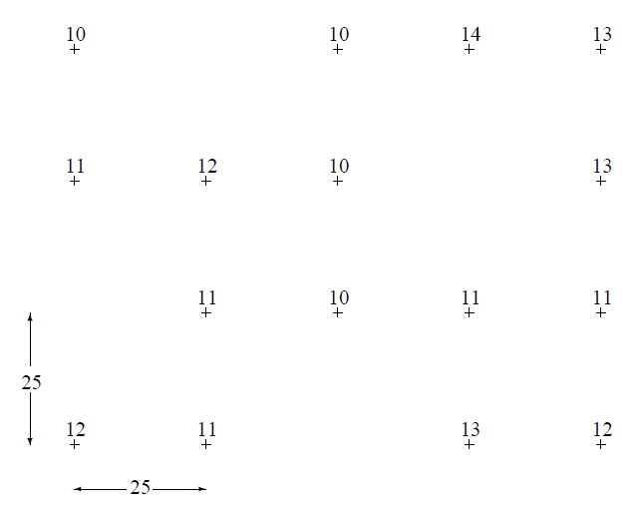
Figure 4: Data configuration and values for example 2

This example does not only show how the values of an experimental variogram
are calculated, but also shows that the contribution of pairs with big differences
is very important. Excluding the data point with the value 14 one has:
$γ\left({25}_{x}\right)=0.643$.
If the number of pairs used for the calculation of the experimental variogram is large this unpleasant effect becomes less important.

Example 3:
Consider the values given in the Figure 5, Which represents a stratiform iron ore body, drilled through a series of wells perpendicular to the slope of the ore. The value given at each location is the average value of Fe ( % by weight) over the intersection of the borehole with ore, essentially this is a two-dimensional problem, so that the h in the definition of semi-variogram depend on the distance between the location of each pair of samples, and their relative orientation in a two-dimensional plan.,
Let now compute the experimental semi-variogram $\hat{γ}\left(h\right)$ , considering east-west direction. Since the grid on which the holes have been conveniently placed is 100ft by 100ft, so that we can calculate the semi-inequalities at distances of 100 feet or multiples thereof.
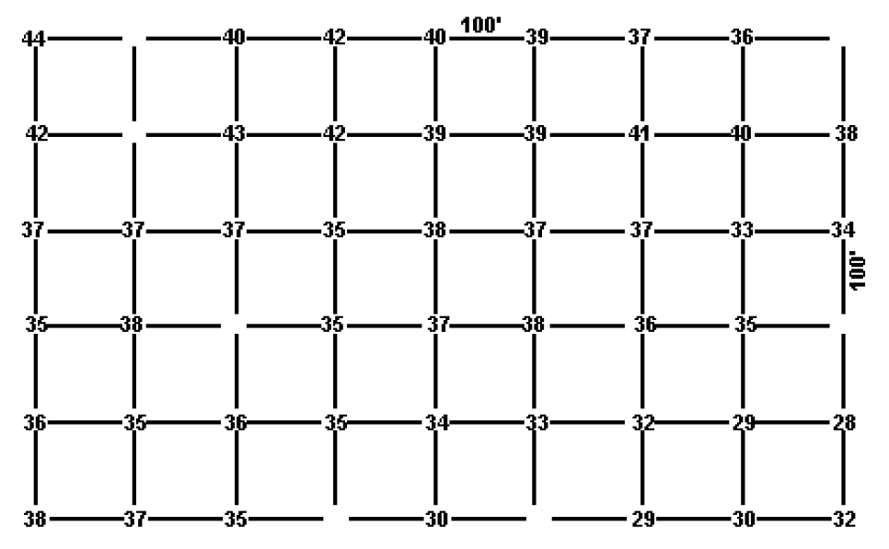
Figure 5: data on the grid for the calculation of the experimental semi-variogram for iron ore.

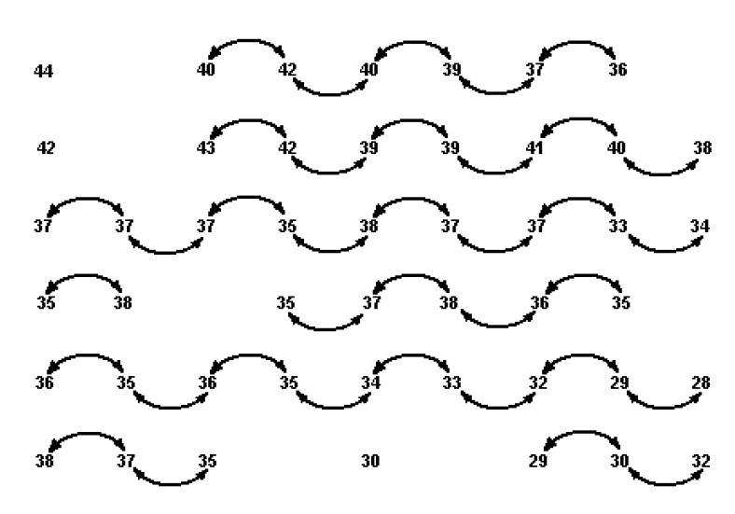
Figure 6: identifying all the pairs at h=100ft apart in the east-west direction.

For h=0 we have:
$\hat{γ}\left(0\right)=0$
For h=100ft we have:
$$\hat{γ}\left(100\right)=\frac{1}{2\left(36\right)}\left[{\left(40-42\right)}^{2}+{\left(42-40\right)}^{2}+{\left(40-39\right)}^{2}+{\left(39-37\right)}^{2}+{\left(37-36\right)}^{2}+{\left(43-42\right)}^{2}+{\left(42-39\right)}^{2}+{\left(39-39\right)}^{2}+{\left(39-41\right)}^{2}+{\left(41-40\right)}^{2}+{\left(40-38\right)}^{2}+{\left(37-37\right)}^{2}+{\left(37-37\right)}^{2}+{\left(37-35\right)}^{2}+{\left(35-38\right)}^{2}+{\left(38-37\right)}^{2}+{\left(37-37\right)}^{2}+{\left(37-33\right)}^{2}+{\left(33-34\right)}^{2}+{\left(35-38\right)}^{2}+{\left(35-37\right)}^{2}+{\left(37-36\right)}^{2}+{\left(36-36\right)}^{2}+{\left(36-35\right)}^{2}+{\left(36-35\right)}^{2}+{\left(35-36\right)}^{2}+{\left(36-35\right)}^{2}+{\left(35-34\right)}^{2}+{\left(34-33\right)}^{2}+{\left(33-32\right)}^{2}+{\left(32-29\right)}^{2}+{\left(29-28\right)}^{2}+{\left(38-37\right)}^{2}+{\left(37-35\right)}^{2}+{\left(29-30\right)}^{2}+{\left(30-32\right)}^{2}\right]=1.46\%^{2}$$
To draw the curve of the experimental semi-variogram $\hat{γ}\left(h\right)$, we can use the point ( 100ft, 1.46$\%^{2}$) which can plot on a graph of the experimental semi-variogram $\hat{γ}\left(h\right)$ versus the distance between the samples (h).
Another point to be gained when we compute the experimental semi-variogram for h=200 in the same direction.
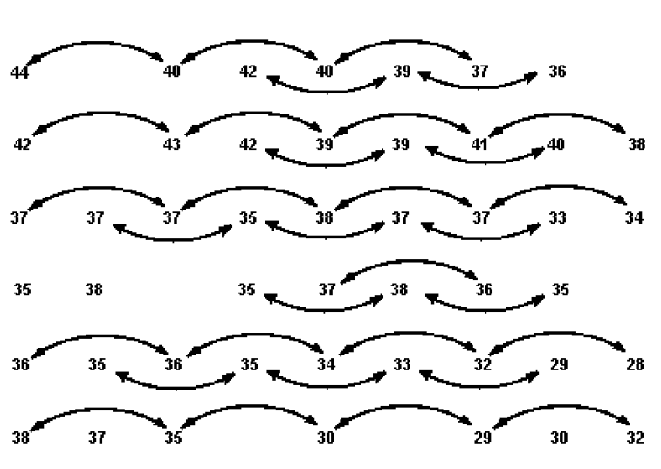
Figure 7: identifying all the pairs at h=200ft apart in the east-west direction.
$$\hat{γ}\left(200\right)=\frac{1}{2\left(33\right)}\left[{\left(44-40\right)}^{2}+{\left(40-40\right)}^{2}+{\left(42-39\right)}^{2}+{\left(40-37\right)}^{2}+{\left(39-36\right)}^{2}+{\left(42-43\right)}^{2}+{\left(43-39\right)}^{2}+{\left(42-39\right)}^{2}+{\left(39-41\right)}^{2}+{\left(39-40\right)}^{2}+{\left(41-38\right)}^{2}+{\left(37-37\right)}^{2}+{\left(37-35\right)}^{2}+{\left(37-38\right)}^{2}+{\left(35-37\right)}^{2}+{\left(38-37\right)}^{2}+{\left(37-33\right)}^{2}+{\left(37-34\right)}^{2}+{\left(38-35\right)}^{2}+{\left(35-36\right)}^{2}+{\left(37-36\right)}^{2}+{\left(36-35\right)}^{2}+{\left(36-36\right)}^{2}+{\left(35-35\right)}^{2}+{\left(36-34\right)}^{2}+{\left(35-33\right)}^{2}+{\left(34-32\right)}^{2}+{\left(33-29\right)}^{2}+{\left(32-28\right)}^{2}+{\left(38-35\right)}^{2}+{\left(35-30\right)}^{2}+{\left(30-29\right)}^{2}+{\left(29-32\right)}^{2}\right]=3.30\%^{2}$$
the value of $\hat{γ}\left(200\right)$ plot on the graph versus h=200ft.
for h = 200 we get the point (200ft, $3.30\%^{2}$), Which can be drawn on the coordinates as the second point. The maximum range between points is 800, which includes 7 pairs, so we can calculate the experimental semi-variogram up to h=800. However, the value of a semi-variogram becomes inaccurate as the fewer points included in the range on which it is based. Therefore, in practice, we depend on half the maximum range. As for our example, we continue calculating the values ​​of the semi-variogram up to 400. Table 1 show the value of semi-variogram for h = 100,200,300,400 in the east-west direction, also this table show the values of semi-variogram for h = 100,200,300 in the north-south direction.
Figure 8 show the plot of the experimental semi-variogram in the two directions.

Table (1): The value of semi-variogram in the east-west, the north-south directions
for each value of (h).
Direction | Distance between samples (h) | experimental semi-variogram | Number of pairs
east-west | 100  200  300  400 | 1.46  3.30  4.31  6.70 | 36  33  27  23
north-south | 100  200  300 | 5.35  9.87  18.88 | 36  27  21
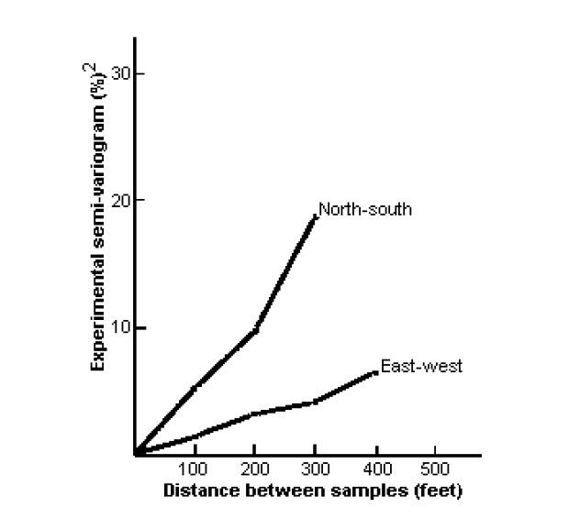
Figure 8: The plot of the experimental semi-variogram in the two directions.

From figure 8 we can see that there appears to be a clear difference in structure in the two directions. The north-south semi-variogram rises more sharply than the east-west, indicating greater continuity in the east-west trend. To verify this, we need to calculate the semi-variogram in at least one diagonal direction, e.g., northwest-southeast, the semi-variogram in the diagonal direction will be calculated for multiples of ( $100\sqrt{2}$ ).
more information is needed to determine the true axis of The Anisotropy.

