Geostatistics:
Outline of the course:
1. Overview
2. Spatial Analysis
3. Experimental Variogram
4. Variogram Modeling
5. Geostatistical Estimation (Kriging & Co-Kriging)
6. Geostatistical Simulation (Unconditional & Conditional)
7. Advanced Topics
1. Overview:
Classic statistics is generally deal with the analysis of any phenomena based on the samples that chosen form the populations that represent these phenomena, these samples which choose randomly assumed that they are independent and normally distributed. Geostatistics however, deviates from classic statistics in that Geostatistics is not tied to a population distribution model that assumes.
Most of the earth science data (e.g., rock properties, contaminant concentrations) often do not satisfy these assumptions as they can be highly skewed and /or possess spatial correlation (i.e., data values from locations that are closer together tend to be more similar than data values from locations that are further apart).
Compared to the classic statistics which examine the statistical distribution of a set of sampled data, geostatistics incorporates both the statistical distribution of the sample data and the spatial correlation among the sample data.
Because of this difference, many earth science problems are more effectively addressed using geostatistical methods.
Geostatistical methods provide the tools to capture, through rigorous examination, the descriptive information on a phenomenon from sparse, often biased, and often expensive sample data.

2. Geostatistical Prediction:
The goal of geostatistics is to predict the possible spatial distribution of a property. Such prediction often takes the form of a map or a series of maps.
Two basic forms of prediction exist: estimation and simulation. In estimation, a single, statistically best estimate (map) of the spatial occurrence is produced. The estimation is based on both the sample data and on a model (variogram) determined as most accurately representing the spatial correlation of the sample data. This single estimate or map is usually produced by the kriging technique. On the other hand, in simulation, many equal-likely maps (sometimes called \images") of the property distribution are produced, using the same model of spatial correlation as required for kriging.
Differences between the alternative maps provide a measure of quantifying the uncertainty, an option not available with kriging estimation.
Geostatistics has played an increasing role in both groundwater hydrology
and petroleum reservoir characterization and modeling, driven mainly by the
recognition that heterogeneity in petrophysical properties (i.e., permeability and
porosity) dominates groundwater flow, solute transport, and multiphase migration in the subsurface.
Geostatistics, by transforming a sparse data set from the field into a spatial map (kriging estimation), offers a means to recreate heterogeneity to be incorporated into numerical flow and transport modeling. On the other hand, by transforming a sparse data set into multiple spatial maps (unconditional/conditional simulations), it offers a means of evaluating the uncertainties on modeling due to the uncertain nature of each map. Note that this uncertainty reflects our lack of knowledge about the subsurface, though the geological \groundtruth", albeit
unknown, is deterministic and certain.

3. Geostatistics versus Simple Interpolation:
In geostatistical estimation, we wish to estimate a property at an unsampled location, based on the spatial correlation characteristics of this property and its values at existing sampled locations. But, why not just use simple interpolation? How is spatial correlation incorporated in the geostatistical approach?
A simple example may illustrate this point more clearly (Figure 1): we know permeability at n sampled locations, we wish to estimate the permeability at an unsampled location, z₀. Using inverse distance, the unknown value can be evaluated as following:

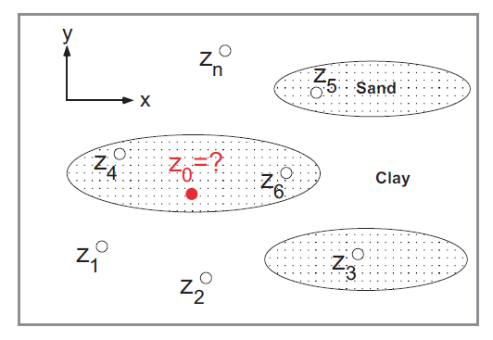
Figure 1: Estimation of the unknown permeability z₀ based on a set of known
values of permeability at n locations.

Let $z_{i}$ , i=1,2,…,n be the permeability measurements at the n sampled locations, and $z_{0}$ be the permeability measurement at the unsampled location, then the estimated of that unknown permeability measurement can obtain as following:

$z_{0}=\sum_{i=1}^{n}{w_{i}z_{i}}$
Where:
$w_{i}=\frac{1/{d_{i}}}{\sum_{i=1}^{n}{1/{d_{i}}}}$

$z_{0}$ is the weighted sum of the n of the known permeability measurement, $w_{i}$ are weights specific to the permeability measurements of the locations from which the samples were taken and are measured based on the distances between the points of the sampled location and the point of the unsampled site for which the permeability estimate is required, here we use the inverse distance.
Suppose that n=7 , then the weights of the 7 known location can simply computed as shown in figure 2:

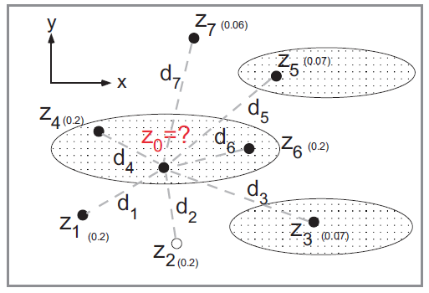
Figure 2: Estimation of the unknown z₀ given 7 known values.

Numbers in parenthesis are weights assigned to the known values based on inverse distance.
Using this scheme, the weights assigned to points 1, 2, 4, and 6 are all equal and equal to 0.2. However, from the understanding of geology, we realize that permeability within the elongated sand body should be more similar in the lateral direction.
Thus, points 4 and 6 should be given higher weights than points 1 and 2. This is
obviously not the case when using inverse distance. Thus, in conventional interpolation methods (e.g., inverse distance, inverse distance squared), information on spatial correlation is not incorporated. On the other hand, geostatistical estimation considers both distance and spatial correlation.
In general, geostatistical estimation consists of 3 steps:

(1) examining the similarity between a set of sample (known) data points via an
experimental variogram analysis.
(2) fitting a permissible mathematical function to the experimental variogram.
(3) conducting kriging interpolation based on this function.

In the above example, the spatial correlation will be revealed by the more similar values of z₄ and z₆ (step (1)). It will be modeled via step (2) (variogram modeling). Then, using kriging, we'll find that the weights assigned to points 4 and 6 will increase (those of 1 and 2 will decrease accordingly since the total weight must sum to 1.0) (step (3)). In kriging, based on the new weights, a best linear unbiased estimate of z₀ is obtained.

4. Spatial distributions and Spatial Central Tendency measurements:
There are statistical indicators used to describe, summarize and analyze spatial data of spatial phenomena in geographical locations in terms of their spatial characteristics and spatial distribution.
Analyzing the spatial dimension of a phenomenon is an essential complement to analyzing the values ​​of the phenomenon itself. Any phenomenon on the Earth's surface requires a spatial analysis in addition to the spatial dimensions and sizes of its observations.
4-1. Spatial Central Tendency measurements:
Measures of spatial central tendency are used to identify intermediate locations, which represent the centers of gravity, or the main points of attraction for these distributions. Geographers use various types of measures of central tendency, such as the arithmetic mean, median, and mode, to identify these centers.
This aims to achieve two main objectives:
The first is to compare the distance between the actual center and the ideal center.
The second is to identify the appropriate intermediate location to be used as a service center.

Spatial mean:
It is the simplest measure that aims to determine the midpoint of any spatial distribution. It is similar to the arithmetic mean of a set of values ​​and is calculated in much the same way.

Spatial weighted mean:
The arithmetic mean gives equal values ​​for each spatial location. This is not true in many spatial distributions, as phenomena differ in their importance from one location to another. Therefore, importance must be taken into consideration when calculating the spatial mean, which calls for the use of the weighted spatial mean.

Example (1):
The following table shows information about ten health centers in a number of residential neighborhoods in a city with an area of ​​65 km, along with the number of population in those residential neighborhoods.

locations | Number of population ( W ) | Coordinates
locations | Number of population ( W ) | X | Y
A | 20 | 1.8 | 2.8
B | 100 | 1.6 | 9.8
C | 19 | 7.8 | 9.8
D | 8 | 8.5 | 4.2
E | 20 | 6.5 | 2.8
F | 14 | 6.2 | 5.8
G | 90 | 4.6 | 7.8
H | 11 | 3.5 | 4.8
J | 10 | 5.4 | 9.8
K | 13 | 8.5 | 0.8
 | 305 | 54.4 | 58.4

We wish to determine the ideal and suitable location to establish a hospital for this city, which has an area of ​​65 square kilometers.
First we use the simple Spatial mean as following:
$\overline{X}=\frac{\sum{X_{i}}}{n}=\frac{54.4}{10}=5.44$

$$\overline{Y}=\frac{\sum{Y_{i}}}{n}=\frac{58.4}{10}=5.84$$
So the location of the hospital is C= ( 5.44 , 5.84 )
This result did not take into the accounts the number of the population in each residential neighborhoods, which represent the importance of each location, so we prefer using the Spatial weighted mean, as following:

$${\overline{X}}_{w}=\frac{\sum{X_{i}W_{i}}}{\sum{W_{i}}}=\frac{1246}{305}=4.1$$

${\overline{Y}}_{w}=\frac{\sum{Y_{i}W_{i}}}{\sum{W_{i}}}=\frac{2256.2}{305}=7.4$
The best location is C= ( $4.1$ , 7.4 )

4-2. Spread measures:
4-2-1. Standard Distance Indicator:
The distance that shows the spread of a group of points around the geographic center point and is calculated according to the following formula:

$SD=\sqrt{\left[\left(\frac{\sum{x^{2}}}{n}-{\overline{x}}^{2}\right)+\left(\frac{\sum{y^{2}}}{n}-{\overline{y}}^{2}\right)\right]}$
For the last example we have:

SD = 3.96
Referring to the previous diagram, we find that there are five points inside the circle whose radius is equal to 3.96 Which is centered on the simple arithmetic mean value, this result indicates the presence of dispersion in the spatial distribution of points, because the homogeneity condition requires that most of the points be within that circle.

4-2-2: The nearest neighbor's spouse criterion:
One of the most popular analyses used by geographers to study spatial distributions. It is used to measure the degree of dispersion of points around each other and to determine their distribution patterns within spatial distributions, which can be random, organized, or concentrated.
It is a means of measuring the degree of concentration or dispersion of geographical features, and is considered a quantitative criterion that indicates the pattern of spatial distribution of the different locations represented by those points.
This criterion is calculated according to the following steps:
- Determine the nearest neighbor for each location.
- Calculate the distance between each location and its nearest neighbor, symbolized by the symbol ( d ).
- Calculate the arithmetic mean of these distances ($\overline{d}$ ) .
- Calculate the expected distance to the nearest neighbor which denoted by $σ^{*}$ , and calculated as following:

$σ^{*}=\frac{1}{2\sqrt{λ}}$

Where: $λ=\frac{number of points}{the area}$

- Calculate criterion of the nearest neighbor's spouse by the following formula:

$R=\frac{\overline{d}}{σ^{*}}$
- The value of the nearest neighbor criterion ranges between 0 and 2.15, and on the value of this criterion we can determined the type of the distribution pattern. The following table shows the type of the distribution patterns according to the value of the nearest neighbor criterion:

The value of the nearest neighbor criterion | the type of the distribution patterns
0 – 0.09 | gathered
0.1 – 0.49 | cluster convergent
0.5 – 0.99 | Random convergent
1 – 1.19 | Random
1.2 – 2.15 | distant

locations | The nearest point | The distant ( d )
A | H | 2.6
B | G | 3.6
C | J | 2.4
D | E | 2.4
E | D | 2.4
F | E | 3
G | J | 2.2
H | A | 2.6
J | G | 2.2
K | E | 2.8

$\overline{d}=\frac{\sum{d_{i}}}{n}=\frac{26.2}{10}=2.62$
$λ=\frac{10}{65}=0.1538$
$σ^{*}=\frac{1}{2\sqrt{0.1538}}=1.2747$
$R=\frac{2.62}{1.2747}=2.055$
The value of R indicate that the type of the distribution pattern is distant. i.e. the points at maximum spread.
This result is consistent with what we have reached based on Standard Distance indicator.

5. Random Variables and Regionalized Variable Theory:
Measurements of any phenomenon in the geographical environment are determined by random processes, in the sense that these measurements are a realization of those processes, so these measurements are random variables. For example, the ph value, at any location, such as x, is just one of the infinite number of values that can be observed in that location. Therefore, each location x is associated not only with one value of the measurements of the particular phenomenon, but a whole set of values with mean, variance, and higher degrees of moment of the distribution for that phenomenon under research, the actual value of this phenomenon at location x is only one value of this distribution that is determined at random. Thus, the value of the variable at the location x is treated as a random variable, and let's symbolize it with the symbol Z. The set of random variables for each x in ℛ forms a stochastic function or a stochastic process. Random variables in real space, which may be one-, two- or three-dimensional, are also called "regional variables", which are subject to the Regionalized Variable Theory.
The measurements of the phenomenon that were observed in different locations may be related to each other and randomly, we would expect those measurements in locations close to each other to be similar, while those in widely separated locations are less likely to be.

5-1. Regionalized variables:
In the theory of regionalized variables, the concept of random functions plays a central role. A random function is a set of random variables corresponding to the
points of the domain D under study. This means that for each point x in D there is
a corresponding random variable Z(x).
A regionalized variable is the realization of a random function. This means that for each point x in the d dimensional space the value of the parameter we are interested in, z(x) is one realization of the random function Z(x). This interpretation of the natural parameters acknowledges the fact that it is not possible to describe them completely using deterministic methods only. In most cases it is impossible to check the assumption that the parameter is the realization of a random function as we have to deal with a single realization.
One could describe a random function by its multidimensional distribution functions. This means that for each set of points x₁, . . ., x_{n} in the domain D, a
cumulative distribution function F_{x1,...,xn} is assigned. Using these functions for each set of possible values w₁, . . . ,w_{n} one could find the probability P :

$P\left(Z\left(x_{1}\right)<w_{1}, …,Z\left(x_{n}\right)<w_{n} \right)= F_{x_{1},{…,x}_{n}}(w_{1},.. , w_{n})$ … 1

This would mean that conditional probabilities could be used for the estimation
of local or global averages etc. Unfortunately, there are infinitely many finite subsets in the domain D, and as for each point in D usually only one value ( the
realization) is available, the assessment of the distribution functions based on the
experimental data seems to be illusory. Even in the case of repeatedly measured
parameters (for example groundwater quality) there are not enough measurements to assess the above distribution functions.
A general hypothesis which reduces the complexity of the problem is the so-called strong stationarity hypothesis.

5-2. Strong stationarity hypothesis:
Strong stationarity hypothesis states the following:
The random function Z(x) is stationary if for each set of points x₁, . . . ,x_{n} in the
domain D, and for each set of possible values w₁, . . . ,w_{n}, and for each vector h:

$P\left(Z\left(x_{1}\right)<w_{1}, …,Z\left(x_{n}\right)<w_{n} \right)=P\left(Z\left(x_{1}+h\right)<w_{1}, …,Z\left(x_{n}+h\right)<w_{n} \right)$
… 2
This equation means that the distribution of the random function depends on the configuration of the points and not on their locations. In other words, this can be formulated that “nature” repeats itself similarly for the same configuration. The assumption of strong stationarity is useful, but still a bit too complex to be appropriate. To deal with the problem effectively some even simpler assumptions have to be made. The two basic and very similar assumptions are the following:

5-3. Second order stationarity hypothesis:
Stationarity is a concept often used in time series analysis. Here the second order
stationarity hypothesis is formulated for multidimensional spaces.
The assumption of second order stationarity consists of two conditions:
a. The expected value of the random function Z(u) is constant all over the domain
D.
b. The covariance of two random variables corresponding to two locations
depends only on the vector h separating these two points.
These conditions can be formulated as:

$E\left(Z\left(x\right)\right)=m$ … 3
For all x∈ D , m is a costant.
$E [ \left(Z\left(x+h\right)-m\right)\left(Z\left(x\right)-m\right)]=C(h)$ …4

For any x , x+h ∈ D , where The function C(h) is called covariance function, which depends only on the vector h and not on the locations x and x+h.
Note that for h=0 , we have

$E \left[ \left(Z\left(x\right)-m\right)\left(Z\left(x\right)-m\right)\right]=C\left(0\right)=Var(Z)$ … 5
Equation (5) shows that the random variables corresponding to different points in the domain do not only have the same expectation, but they also have to have the same finite variance. This second condition is not always met, but weaker assumptions can be formulated.

5-4. Intrinsic stationarity hypothesis:
The assumption slightly weaker than the second order stationarity is the so called intrinsic stationarity. The first condition is the same as in the case of second order stationarity, only the second is different:
a. The expected value of the random function Z(u) is constant all over the domain D.
b. The variance of the increment corresponding to two different locations depends only on the vector separating them.
These conditions can be formulated as:

$E\left(Z\left(x\right)\right)=m$

$\frac{1}{2}V\left[\left\{ Z\left(x+h\right)\right\}- \left\{ Z\left(x\right)\right\}\right]=\frac{1}{2}E\left[{\{Z\left(x+h\right)-Z\left(x\right)\}}^{2}\right]=γ(h)$ …6

Where γ(h) depends only on the vector h and not on the locations x and x+h. The function γ (h) is called semi-variogram. The semi-variogram is often called simply variogram, for convenience this sloppy convention will be used throughout this
text. One can see that equation (6) is very similar to (4), but the implicit assumption of the finite variance is not included. It can be demonstrated that the
second order stationarity implies the intrinsic hypothesis, but the converse is not
true. In the case of second order stationarity, one has:

$E\left[{\left\{Z\left(x+h\right)-Z\left(x\right)\right\}}^{2}\right]= E\left[{\left\{\left( Z\left(x+h\right)-m\right)-\left( Z\left(x\right)-m\right)\right\}}^{2}\right]$

$$=Var\left(Z\left(x\right)\right)+Var\left(Z\left(x+h\right)\right)-2E\left[\left( Z\left(x+h\right)-m\right)\left( Z\left(x\right)-m\right)\right]$$
$=2C\left(0\right)-2C(h)$
This mean that:

$γ\left(h\right)=C\left(0\right)-C(h)$ …7

Eq. 7 represent the relationship between the covariance function and the variogram, the following figure show this relationship:

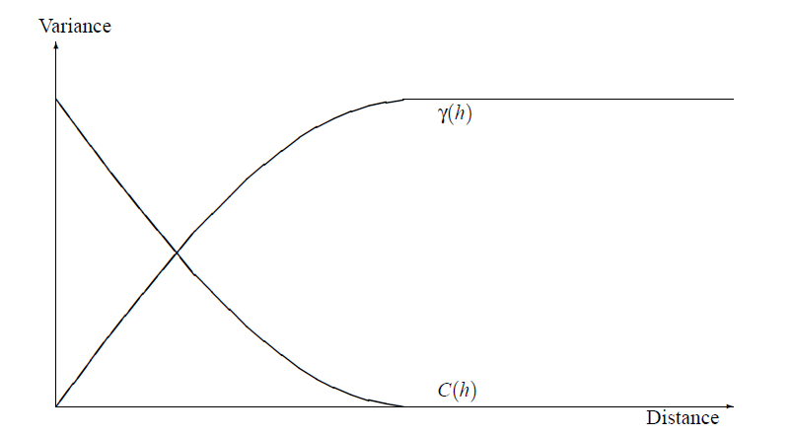
Figure 1: The covariance function C(h) and the variogram γ(h).

The difference between the intrinsic stationarity and the second order stationarity is not only the fact that the first is more general than the second. The covariance function (4) is defined using the value of the expectation m, while the variogram (6) does not depend on this value. This is an advantage because slight trends do not influence the variogram severely, in contrast to the covariance function where through the improper estimation of the mean these effects are more severe.

5-5. Selection of the regionalized variable:
The regionalized variable under study has to fulfill certain conditions to apply geostatistical methods. These conditions are:
1. Data homogeneity: The data should reflect one parameter, measured by the same measurement method, and the measurements should be made on the same volume.
2. Additivity: The parameter should have the property that $\frac{1}{n}\sum_{i=1}^{n}{Z(x_{i})}$ has the same meaning as Z(x).
To understand the meaning of the additivity condition, consider the following example:

Example:
Suppose that Z(x) represents the thickness of a layer measured in meter. If the average thickness over a certain area is needed, then the arithmetic mean of a regular sampling is a good estimator for this. If instead Z∗(x) is the cube of the thickness, then the arithmetic mean of the individual Z∗(x_{i}) values is not the cube of the mean thickness. To see this explicitly suppose two samples are available:
Z(x₁) = 1 and Z(x₂) = 2. So Z∗ (x₁) = 1 and Z∗ (x₂) = 8. Then for the mean one has:

$$0.5Z\left(x_{1}\right)+0.5Z\left(x_{2}\right)=1.5$$

And $0.5Z^{*}\left(x_{1}\right)+0.5Z^{*}\left(x_{2}\right)=4.5$
But the cube of the mean thickness is:

$${( 0.5Z\left(x_{1}\right)+0.5Z\left(x_{2}\right) )}^{3}=3.375$$

This mean that Z∗ (x) is not additive.
Some natural parameters are clearly non additive, like hydraulic conductivity etc. In the case of non-additive parameters, it is possible to use transformations which transform them to additive ones.

