Value Chain and Supply Chain Analysis and Key Success Factors
Value chain is the sequence of business functions in which customer usefulness is added to products.

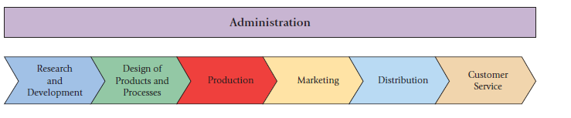

Supply chain
describes the flow of goods, services, and information from the initial sources of materials and services to the delivery of products to consumers, regardless of whether those activities occur in the same organization or in other organizations.
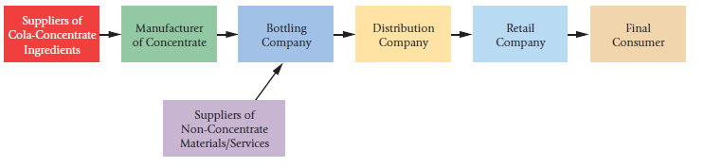
Key Success Factors
Customers want companies to use the value chain and supply chain to deliver ever improving levels of performance regarding several (or even all) of the following:
_ Cost and efficiency—Companies face continuous pressure to reduce the cost of the products they sell. To calculate and manage the cost of products, managers must first understand the tasks or activities (such as setting up machines or distributing products) that cause costs to arise. They must also monitor the marketplace to determine prices that customers are willing to pay for products or services. Management accounting information helps managers calculate a target cost for a product by subtracting the operating income per unit of product that the company desires to earn from the “target price.” To achieve the target cost, managers eliminate some activities (such as rework) and reduce the costs of performing activities in all value-chain functions—from initial R&D to customer service. Increased global competition places ever-increasing pressure on companies to lower costs. Many U.S. companies have cut costs by outsourcing some of their business
functions. Nike, for example, has moved its manufacturing operations to China and Mexico. Microsoft and IBM are increasingly doing their software development in Spain, eastern Europe, and India.
_ Quality—Customers expect high levels of quality. Total quality management (TQM) aims to improve operations throughout the value chain and to deliver products and services that exceed customer expectations. Using TQM, companies design products or services to meet the needs and wants of customers and make these products with zero (or very few) defects and waste, and minimal inventories. Managers use management accounting information to evaluate the costs and revenue benefits of TQM initiatives.
_ Time—Time has many dimensions. New-product development time is the time it takes for new products to be created and brought to market. The increasing pace of technological innovation has led to shorter product life cycles and more rapid introduction of new products. To make product and design decisions, managers need to understand the costs and benefits of a product over its life cycle. Customer-response time describes the speed at which an organization responds to customer requests. To increase customer satisfaction, organizations need to reduce delivery time and reliably meet promised delivery dates. The primary cause of delays is bottlenecks that occur when the work to be performed on a machine, for example, exceeds available capacity. To deliver the product on time, managers need to increase the capacity of the machine to produce more output. Management accounting information helps managers quantify the costs and benefits of relieving bottleneck constraints.
_ Innovation—A constant flow of innovative products or services is the basis for ongoing company success. Managers rely on management accounting information to evaluate alternative investment and R&D decisions.

