Introduction To Management Accounting
Management accounting: an accounting information system, measures, analyzes, and reports financial and nonfinancial information that helps managers make decisions to fulfill the goals of an organization. Managers use management accounting information to develop, communicate, and implement strategy. They also use management accounting information to coordinate product design, production, and marketing decisions and to evaluate performance. Management accounting information and reports do not have to follow set principles or rules. The key questions are always (1) how will this information help managers do their jobs better, and (2) do the benefits of producing this information exceed the costs?
Major deference’s between management and financial accounting
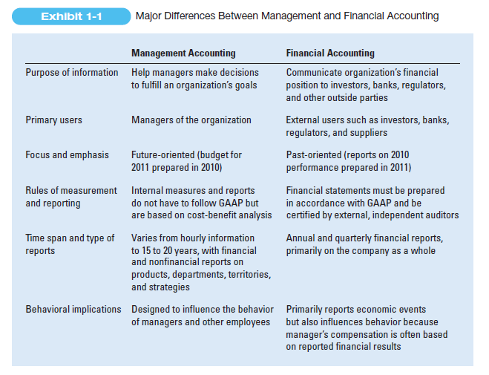

Strategic cost management describes cost management that specifically
focuses on strategic issues. Management accounting information helps managers formulate strategy by answering questions such as the following:
_ Who are our most important customers, and how can we be competitive and deliver value to them? After Amazon.com’s success in selling books online, management accountants at Barnes and Noble presented senior executives with the costs and benefits of several alternative approaches for building its information technology infrastructure and developing the capabilities to also sell books online. A similar cost-benefit analysis led Toyota to build flexible computer-integrated manufacturing (CIM) plants that enable it to use the same equipment efficiently to produce a variety of cars in response to changing customer tastes.
_ What substitute products exist in the marketplace, and how do they differ from our product in terms of price and quality? Hewlett-Packard, for example, designs and prices new printers after comparing the functionality and quality of its printers to other printers available in the marketplace.
_ What is our most critical capability? Is it technology, production, or marketing? How can we leverage it for new strategic initiatives? Kellogg Company, for example, uses the reputation of its brand to introduce new types of cereal.
_ Will adequate cash be available to fund the strategy, or will additional funds need to be raised? Proctor & Gamble, for example, issued new debt and equity to fund its strategic acquisition of Gillette, a maker of shaving products.

