Curriculum Vitae
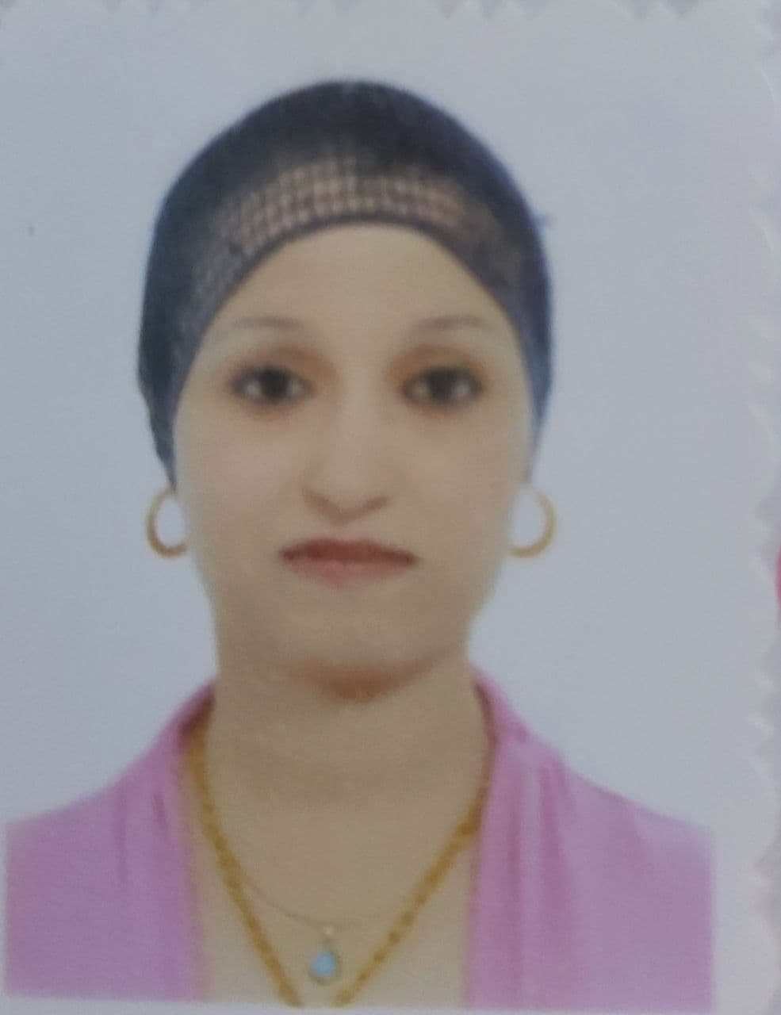
Lecturer. Wedyan Ghalib Nasif
Mustansiriyah University – College of Sciences – Atmospheric Science Department (Atmospheric Dynamics)
Mobile: +9647704292441
Email: wedyan.atmsc@uomustansiriyah.edu.iq
Personal Summary:

- Full Name: L. Wedyan Ghalib Nasif AL-atabi
- Scientific Title: Lecturer.
- Date and Place of Birth: 18/4/1981 – Baghdad – Iraq.
- Marital Status: Married.
- Email (alternative): wedyan.ghalib@yahoo.com
- Page profile, Academic of Mustansiriyah Univ.: https://uomustansiriyah.edu.iq/e-learn/UOMTeach/index.php
- ResearchGate: https://www.researchgate.net/profile/Wedyan-Ghalib
- ORCID: http://orcid.org/0000-0001-5619-4359
- Google Scholar Citations: https://scholar.google.com/citations?hl=ar&user=DSGn0yQAAAAJ
- Scopus profile: https://www.scopus.com/authid/detail.uri?authorId=57217129359

Education:

.
- M.Sc. in Applied meteorology and hydrology, 2015 from Russian State University for the Meteorological.
- B.Sc. in Meteorology, 2004 from Mustansiriyah University, Baghdad, Iraq.

ACADEMIC HONORS AND AWARDS:

- Honoring shield the College of Science of the best teaching in the Department of atmospheric Sciences for the year 2012 From Dean College of Science, Mustansiriyah University.
- Honoring shield the College of Science of the best Research published in reputable scientific Journals for the year 2021 From Mustansiriyah University President and Dean College of Science.

- Thankfulness:
- I got a letter of acknowledgment awarded by the chairman of Al-Mustansiriyah University in2008.
- . I got a letter of acknowledgment awarded by the Dean of the College of Science/ Al-Mustansiriyah University in 2010
- I got a letter of acknowledgment awarded by the minster of higher education and scientific research of Iraq in 2012.
- I got a letter of acknowledgment awarded by the chairman of Al-Mustansiriyah University in 2014.
- I got a letter of acknowledgment awarded by the Dean of college of science in 2015
- I got a letter of acknowledgment awarded by the chairman of Al-Mustansiriyah University in 2016
- I got a letter of acknowledgment awarded by the chairman of Al-Mustansiriyah University in 2017.
- I got a letter of acknowledgment awarded by the Dean of college of science in 2017.
- .I got a letter of acknowledgment awarded by the chairman of Al-Mustansiriyah University in 2018.
- I got a letter of acknowledgment awarded by the Dean of college of science in 2018.
- I received a certificate of appreciation from the Minister of Youth and Sports in 2019.

ACADEMIC /TEACHING EXPERIENCE:

- 2006-2012: Assistant Lecturer, Department of Atmospheric Sciences, College of Science, Al-Mustansiriya University, Baghdad, Iraq.
- 2015-2021: Lecturer and Supervisor of Atmospheric Thermodynamics Fundamentals Laboratory Lectures and Supervisor of Air Pollution Laboratory in the Department of Atmospheric Sciences, College of Science, Al-Mustansiriya University, Baghdad, Iraq.
- 2021 - now: Lecturer in the Department of Atmospheric Sciences, College of Science, Al-Mustansiriya University, Baghdad, Iraq.
- Undergraduate:
More than (15) years of teaching experience in the Department of Atmospheric Sciences (Meteorology, Fundamentals of Thermodynamics, Analytical Analytics, Atmosphere, Remote Sensing, Air Pollution, Computer Science etc.). Supervising and participating in the panel discussion for B. Sc. Students in the Department of Atmospheric Sciences.

COURSES TAUGHT:

Undergraduate
Air Pollution lab – (fourth class)
Thermodynamic Basics Lab – (second class)
Atmospheric Lab – (First class)

PROFESSIONAL AFFILIATIONS:

• Member of the College of Media at Al-Mustansiriya University (since 2015).
• Member of the Central Admission for University Studies (2006-2007).
• Participation in committee exams (2007 - 2015 - 2016 - 2019 - 2020).
• Participation in many committees in the Department of Atmospheric Sciences, the college and the university.

PUPLICATIONS:

[1] Osama T. Al-Taai and Wedyan G. Nassif (2020). The Relationship between Soil Temperature and Volumetric Soil Water Content in Iraq using ECMWF Data for the Period (1980-2016). Journal of Physics: Conference Series, 1530(2), 012138. (SCOPUS)
[2] Osama T. Al-Taai and Wedyan G. Nassif (2020). The Relationship between Winds and Rainfall over Selected Stations in Iraq. Plant archives, 20(Supplement 2), 1117-1121. (SCOPUS)
[3] Sara A. Mute, Wedyan G. Nassif, Zahraa A. Al-Ramahy and Osama T. Al-Taai (2020). Analysis of Seasonal and Annual Relative Humidity Using GIS for Selected Stations over Iraq during the Period (1980-2017). Journal of Green Engineering, 10(10), 9121-9135. (SCOPUS)
[4] Wedyan G. Nassif, Zahraa A. Al-Ramahy, Sara A. Muter and Osama T. Al-Taai (2020). Effect of Variation of Rainfall, Soil Moisture and Evaporation in Baghdad City. Plant archives, 20(2), 7739-7744.
[5] Osama T. Al-Taai and Wedyan G. Nassif (2020). Impact Rainfall on the Aerosols Optical Thickness over Selected Stations in Iraq. IOP Conference Series: Materials Science and Engineering, 928(1), 072053. (SCOPUS)
[6] Wedyan G. Nassif, Osama T. Al-Taai and Zainab M. Abbood (2020). The Influence of Solar Radiation on Ozone Column Weight over Baghdad City. IOP Conference Series: Materials Science and Engineering, 928(1), 072089. (SCOPUS)
[7] Wedyan G. Nassif, Osama T. Al-Taai and Sara A. Muter (2021). Inference of Dynamically Dust Storms by Relying on Aerosolos Optical Thickness in Iraq. Journal of Green Engineering, 11(1), 530-546. (SCOPUS)
[8] Zainab M. Abbood, Osama T. Al-Taai and Wedyan G. Nassif (2021). Impact of Wind Speed and Direction on Low Cloud Cover over Baghdad City. Current Applied Science and Technology, 21(3), 590-600. (SCOPUS)
[9] Wedyan G. Nassif, Osama T. Al-Taai, Ali J. Mohammed and Hasanain K. A. AL-Shamarti (2021). Estimate Probability Distribution of Monthly Maximum Daily Rainfall of Iraq. Journal of Physics: Conference Series, 1804(1), 012078. (SCOPUS)
[10] Wedyan G. Nassif, Farah H. Jasim and Osama T. Al-Taai (2021). Analysis of Air Temperature, Relative Humidity and Evaporation over Iraq Using ECMWF Reanalysis. Indian Journal of Ecology, 48(2), 446-452. (SCOPUS)
[11] Majeed, Husam T., Wedyan G. Nassif, and Yasmin Q. Tawfeek. "Effects of meteorological parameters on surface concentration of carbon monoxide over Iraq." J. Green Eng 10, no. 9 (2020): 5927-5940. (SCOPUS)
[12] Nassif, Wedyan G., Basim I. Wahab, Monim H. Al-Jiboori, and Abdulrahhman B. Ali. "Temporal and Spatial Analysis of Alpha and Beta Activity Concentration at Al-Tuwaitha Site, Baghdad." Nature Environment and Pollution Technology 19, no. 4 (2020): 1499-1505. (SCOPUS)
[13] Nassif, Wedyan G., Hussain Abodi Nemah, and Basim Abdul Sada. "STUDY OF GEOPOTENTIAL HEIGHT VALUES AND ITS INRACTION WITH TEMPERATURE DEGREE OVER BAGHDAD CITY, IRAQ." Plant Archives 20, no. 2 (2020): 1388-1391. (SCOPUS)

PROFESSIONAL DEVELOPMENT:

- Certifications:
1.Internet and Basic Computing Certification (IC3), 2011.
2 . Certificate of the Computer Course for the Fifth Scientific Promotion at the Computer Center - Al-Mustansiriya University from 20/05/2012 to 28/02/2012, and a very good grade 2012.
3 . Certificate from the International Conference on Modern Applications of Information and Communication Technology at Imam Al-Kadhim College, held in Baghdad, Iraq on January 11-12, 2020.
4 . Certificate from the International Conference of the Ministry of Higher Education and Scientific Research Al Ain University The Second International Scientific Conference held in Egypt 2020
5 . Certificate from the International Conference on Modern Applications of Information and Communication Technology at Babylon University October 22-23, 2020
6 . Certificate from the International Conference on Atmospheric Sciences at Al-Mustansiriya University, September 21, 2020

- Conferences:
Participation for many international and domestic conferences:
1. The International Conference on Modern Applications of Information and Communication Technology at Imam Al-Kadhim College, Baghdad, Iraq on January 11-12, 2020.
2. The International Conference of the Ministry of Higher Education and Scientific Research Al Ain University The second international scientific conference held in Egypt 2020
3. The International Conference on Modern Applications of Information and Communication Technology at the University of Babylon 22-23 October 2020 held in Babylon - Iraq
4. The International Conference on Atmospheric Sciences at Al-Mustansiriya University September 21, 2020
5 . The Eighth International Conference on Biotechnology, Environment and Engineering Sciences
October 18, 2020, Stockholm - Sweden
- Workshops:
Participation in workshops on renewable energies held in the Al-Mamon University College, 2019.

