Curriculum Vitae
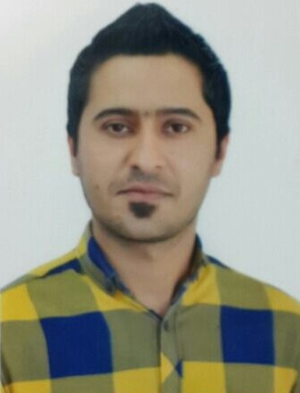

Estabraq Mohammed Ati

Position: Teaching Assistant in the Department of Life Sciences / Faculty of Science,
Al- Mustansiriya University

Marital Status: Married

Date of Birth: 22/07/1988

Nationality: Iraqi

Address: Baghdad

Mobile: +9647905445376
Email: istabraqmohammed@gmail.com , estabraqati@uomustansiriyah.edu.iq

ACADEMIC QUALIFICATIONS

Grad | From - To | Major Subjects | Faculty | Degrees | University / Institute
- | 2015-2017 | Botany/ Environmental | Biology | Master | Al-Mustansiryah University
86.3 | 2007-2010 | General | Biology | Bsc. | Al-Mustansiryah University

PROFESSIONAL COURSES

Place , Authority | Field | Course Description | Year
Faculty of Science, University of Mustansiriyah | Biology | PCR Training Course | 2012
Faculty of Science, University of Mustansiriyah | Biology | First Aid Course | 2012
Faculty of Science, University of Mustansiriyah | Biology | Seminar smoking damage | 2013
Faculty of Science, University of Mustansiriyah | Biology | Creativity Training and Human Development and Management | 2014

OTHER SKILLS:

1-Language : English , Arabic ( Native Language )
2-IT and IC3 Computer Driving License (ECDL).
3-Competent user of Microsoft packages including PowerPoint, Word and Excel.
4-Proficient user of SPSS, Stata and Access and Sigma ploit analyses.

REFERENCES Supervisor :

Publication :

1-ANTIBIOGRAM TYPING AND ERIC-PCR GENOTYPING OF ESCHERICHIA COLI ISOLATED FROM DIFFERENT CLINICAL SAMPLES.(2014). WORLD JOURNAL OF PHARMACY AND PHARMACEUTICAL SCIENCES. Volume 3, Issue 7, 27-37.

2 - Detection of the production of vital membranes by Bacteriaecherichia coli and study the inhibitory effect of honey on its growth (2014). Journal of Science of Mustansiriya. Volume 25, No. 2. ( in Arabic).

3- Bioindicator of Mercury and Isotope Stable Radioactive Elements in Missan Marshlands by Geographic Information Systems (GIS) (Master Thesis 2017). pp

4- Bioindicator Mercury of Aquatic Ecosystems in Iraqi Marshland by Using GIS B.Sc. Estabraq Mohammed Ati, Dr. Reyam Naji Ajmi International Journal of Scientific & Engineering Research, Volume 8, Issue 3, March-2017 ISSN 2229-5518 .

5- Reyam Naji Ajmi*, Istabraq Mohammed Ati, Hayder Nabeel, Mohammed Amer Abbas, Hussen Ahmed Sherif and Oday Abdulhameed PREPARATION OF DIRECT ACTIVATED CARBON FROM TYPHA DOMINGENSIS IN AL-DALMAGE MARSH Plant Archives Vol. 18 No. 1, 2018 pp. 745-748 ISSN 0972-5210 .

6- Dr. Reyam Naji Ajmi , Dr. Aqeel Lami , Estabraq Mohammed Ati Detection of Isotope Stable Radioactive in Soil and Water marshes of southern Iraq Journal of Global Pharma Technology JGPT V(10) No. (9-10) 2018 ISSN 0975-8542.

7- Dr.Reyam Naji Ajmi ,Dr.Huda Farooq Zeki ,Estabraq Mohammed ,Dr.Hadeel Radawi Al-Newani Monitoring of Some Heavy Metals Transboundary Air Pollution Journal of Engineering and Applied Sciences 2018/November) Vol:18 (No.:19-20 ISSN: 1816-949X.

