Curriculum vitae
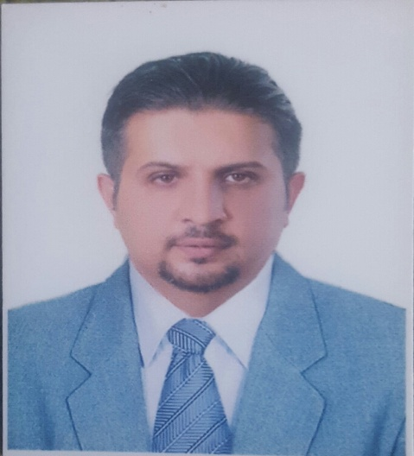

Personal information
Name: Ali Adil Abdallah Al-Shaikhli
Address: Iraq-Baghdad-al-Shabaab quarter. Q.839 S. 19 No. 5.
Phone: 009647901529676
E-Mail: aliadil812012@gmail.com

Scientific certifications

- Senior lecturer, department of surgery, Almustansiriyah
college of medicine April 2014.
- Fellowship of the Iraqi council for medical specialization in general surgery December 2013.
- M.B.CH.B from Almustansiriyah college of medicine, July 2005.

Professional experience:
- From April 2014 till now working as senior lecturer to the 3rd , 4th and 6th grade in almustnsirish college of medicine.
- Participant in small group teaching to the 2nd and 3rd in Almustansiriyah college of medicine in 2015.
- Senior lecturer to the 5th grade of Almustansiriyah college of pharmacy from November 2014 to May 2015.
- From October 2008 to November 2013 worked as senior house officer in general surgery in AL Yarmouk teaching hospital as part of Iraqi board specialization in general surgery distributed as:

- Senior house officer in general surgery........ one year
- Senior house officer in emergency ....... 3 months
- Senior house officer in urology..............3 months
- Senior house officer in burn and plastic surgery... 3 months.
- Senior house officer in cardiothoracic surgery in Ibn Alnafees hospital......... 3 months.
- Return as senior house officer in general surgery from October 2009 to October 2013.

- From January 2008 to October 2008 worked as a doctor in surgery department in almustansririyah college of medicine.
- From January 2006 to October 2007worked as a house officer in AL Yarmouk teaching hospital dealing with:
- Medicine and its emergency ... 6 months.
- Surgery and its emergency......15 months.
- From October 2007 to January 2008 worked as a house officer in paediatric in child central teaching hospital.

