
Ministry Of Higher Almustansiryia University
Education & Scientific College of Science
Research

( Curriculum Vita "CV" )
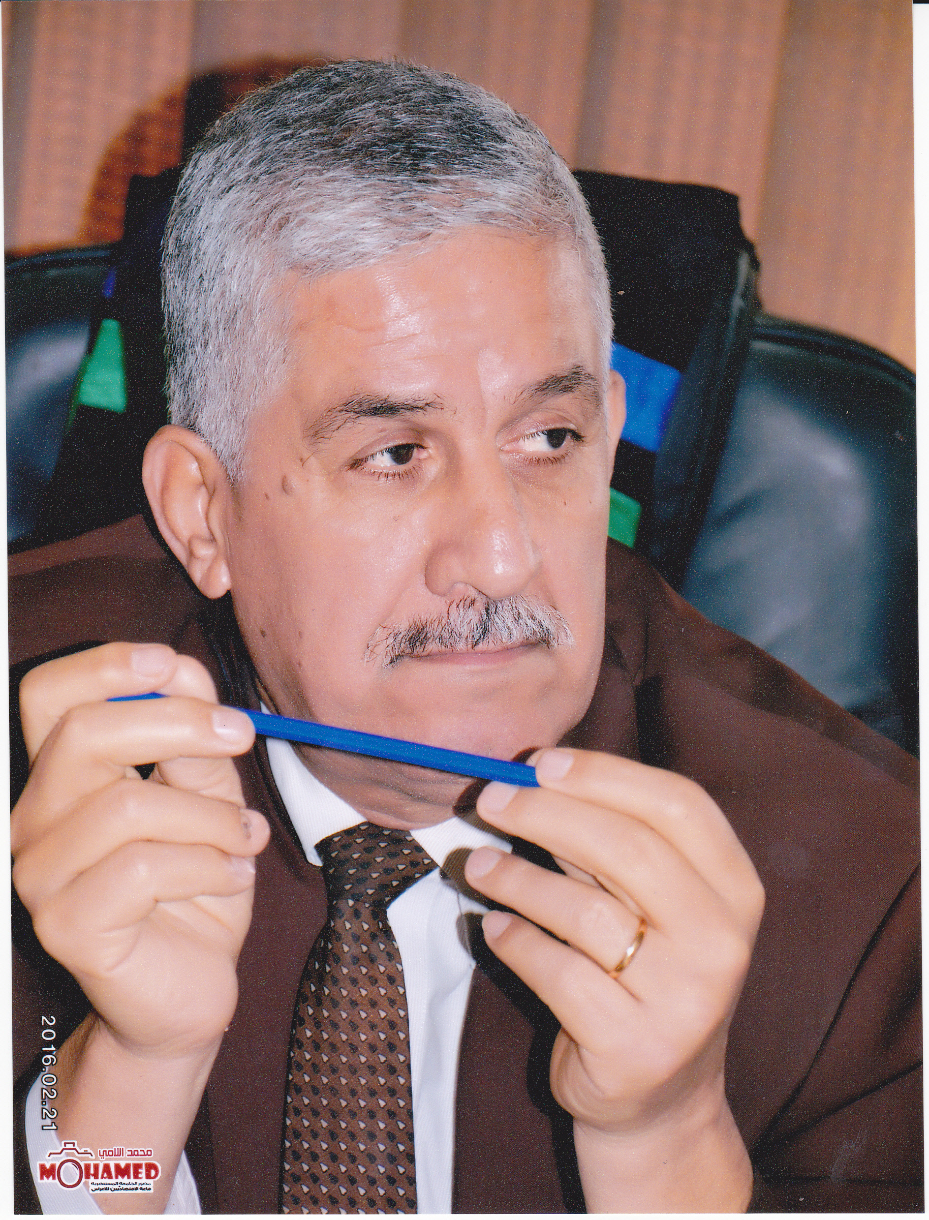

Full Name : Alaa Kamal Jabbar Alhamd

Date of Births : 01/ 07/ 1953
Place of birth : Baghdad / Iraq

E mail : prof.alaaalhamd@yahoo.com
Mobil : 07901516668
Gender : Male
Marital Status : Married
Name of Wife: Hana Hameed Majeed -1958 Chemical Engineering
Nationality : Iraqi

Address : : Baghdad\ Alkarch \ Al-Saydeya ( 835 ) Lane: ( 5 ) House No:(8)
:

Scientific Title: Head of Researchers
Assistant Professor

Perfection of Languages:

1.) Mother language (Arabic).
2.) English language.

Scientific Societies:

1. Member of Iraqi chemists union.
2. Member of Iraqi nuclear medicine society.
3. Member of Arabic chemists union.

(1-7)
Previous Educational Qualification :

Degree | Certificate/Degree | Country | University/Board | Year
B.Sc. in chemistry | College Of Science | Iraq | Al-Sulaimaniyah | 1976
M.Sc. in Clinical Biochemistry | College Of Science | Iraq | Al-Mustansiriya | 1998
Ph.D in Clinical Biochemistry | College Of Science | Iraq | Al-Mustansiriya | 2003

The titles of thesises:

1- M Sc. Degree Thesis: Optimization Separation and Determination of Catecholamine and Their Relation with Parkinson Disease.

2- Ph. D. Degree Thesis: Biochemical Evaluation of Polyamines and follow up the Progress in Different Types of Carcinoma .

Responsibilities:

Title | Date | Place
Assistant Researcher | 1979-1981 | scientific research centre
Assistant Researcher . Head of Radio pharmaceutical Kits production Section | 1981-1990 | scientific research centre
Scientific Researcher | 1990-1997 | scientific research centre
Scientific Researcher, head of scientific training department, Institute of training workers in Iraqi atomic agency, & Lecturer | 1997-2004 | scientific research centre & Al-Mustansiryia University, College of Sciences
Scientific Researcher , head of analytical department , Lecturer | 2004-2007 | scientific research centre in ministry of sciences and technology, chemical research centre & College of Electronic And Electrical
Assistant Professor | 2007-2012 | Al-Mustansiryia University, College Of Pharmacy
Assistant Professor | 2012- | College Of Sciences
(2-7)

Experiences:
1. Production of radioisotopes.
2. Production and equality control of radio pharmaceuticals.
3. Material science( Preparation and characterization of Superconductor ).
4. HPLC-Technique in medical chemistry assessment.
5. Instructor of B Sc. , M Sc & Ph D. of biochemistry and clinical chemistry .
6. Supervision of B. Sc. projects in chemistry .
7. Clinical evaluation of some pharmaceutical Kits Labeled with Tc-99m.
8. Peaceful applications uses of atomic energy.
9. Biochemical marker studies.
10. Pharmacokinetics and Bioavailability of Drugs.

Conferences:
1. Experimental workshop on high temperature superconductors and related materials , International centre for theoretical physics , Trieste, Italy, 12-30 March 1990
2.The eleventh chemical conference , Baghdad, Iraq, (28—31)March (1983) .
3. Golden Jubillee conference , College of Pharmacy ,University of Baghdad, ( 2—4) April (1988).
4. First Specialized conference of Physics and Mathematics Researches, 8—9 October (1991).
5. Second Scientific Conference Of Iraqi Atomic energy Commission, 21—23 November (1989), Baghdad , Iraq.
6.First conference of Materials and Physics , Atomic energy Commission, 25—27 April (1999), Baghdad , Iraq.
7. Analytical Chemistry Conference , College of Science, Saddam University , 9—10 October (1999) .
8. First Scientific Conference Alrazee Center for research And Diagnostic Kits 30—31 March (2009).
9. Second Scientific Conference For Genetic Engineering And Biotechnology for post graduated, 4—5 November (2009)
10. Experimental Workshop On High Temperature Superconductors And Related Materials By (Basic Activities), Held at the International Center For Theoretical physics. March- 1990.
11. First united emirates conference on pure and applied chemistry(ECPAC11), In paper " Clinical Evaluation Of polyamines in breast cancer patients…." Held at American University of Sharjaah during the period March 1—3 2011.
12.The first annual scientific meeting of the meddile-Eastern Association for Cancer Research In Paper "Clinical Evaluation Of Categholamine …" Held at the convention , Medical Campuses of " Tanta – Egypt" From December 27—29 , 2011
13. Assiut Uinversity 8th International Pharmaceutical Sciences Conference , Faculty of Pharmacy Assuit March 14th & 15th , 2012 in paper " HPLC Technique For Estimation of catechol amine using as biochemical brain tumor marker.
(3-7)
Number of published researches: 31

Publications:

1.Alaa K. Jabbar, Saad H. Al-kouraishi, Majad A. Zia,(1988).Labelling and quality control of cystiene with Tc-99m and biodistribution. J. Radio. Anal. And Nucl.Chem.,Article,125(1)213 .
2.Alaa K. Jabbar, Saad H. Al-kouraishi, Majad A. Zia,(1988).Labelling and quality controlof gentamicin with Tc-99m and biodistribution . J. radio. Anal. & Nucl. Chem., Article , 125(1) 203.
3.Alaa K. Jabbar, Hussam M. Abudl-karim, Mousa A. Al-janabi, (1990).Preparationof B-alanine A new freeze-dried kit to be labeled with Tc-99m for liver scintigraphyJ. Radio. Anal.AndNucl.Chem.Article, 140(2) 379.
4. R. K. Itawi, Alaa K. Jabbar, A. A. Abas, Amar H. Al-degili, (1995). Gamma ray radiation induce polymerazation of some acrylocompounds.Iraqi J. Sci. Vol. 36 ,No. 4, 1303.
5.Raad K. Muslih, Alaa K. Jabbar, Fadil M. Abid,(1999).HPLC-Technique for separation of noradrenaline, adrenaline and dopamine on SCX-Column.Iraqi J. Chem.,Vol 25,No(1) 100---105.
6.Alaa K. Jabbar, Raad K. Muslih, Fadil M. Abid,(1999). Rp-HPLC-Technique for separation of noradrenaline, adrenaline and dopamine on ODS-DB column.IraqiJ. of Chem.,Vol.25,No(2) 274—279
7.Alaa K. Jabbar, Raad K. Muslih, Fadil M. Abid,(2002).The practical comparison study between SCX,ODS-DB columns on HPLC technique for separation and determination of catecholamines. Iraqi J. of Chem. Vol 28 , No. (1) 133—139 .
8. Alaa K. Jabbar, Raad K. Muslih, Fadil M. Abid,(2002).Influence of different concentrations of Ion-pairing reagent on the predication of NE, E and DA retention on Rp-HPLC technique. Iraqi J. of Chem. Vol 28 , No. (1) 541--547
9. Alaa K. Jabbar, Raad K. Muslih, Fadil M. Abid,(2002). Pharmacokintic of Dopamine and Levo- dopa on HPLC technique. Iraqi J. Of Chem., Vol 28 ,No(2) 373—379 .
10.Alaa K. Jabbar, Raad K. Muslih , Fadil M. Abid,(2003).HPLC-technique for separation and determination of noradrenaline, adrenaline and dopamine in sera of male patients with parkinsons disease. Iraqi J. of Chem.,Vol 29 ,No.(1)137 .
11.Alaa K. Jabbar, Najim A. Askouri, Kadim Q. Al-janabi,(2001). Preparation of High singl Phase Y₁Ba₂Cu₃O₆._{5+δ} superconductor. Sci. J. Iraqi atomic energy commission. Vol 3 ,No. (1) 192 .,
12.Alaa k. Jabbar , Mohamad Q. Karim , (2002). Preparation And Characterization of Y₁Ba₂ Cu_{3-x} Fe_{x}O_{y} Compound (X=0.05 and 0 .15). J. of Education College,Al-mustansiryia University , Vol ,No(7) 171 .
13.Alaa K. Jabbar, Mohamad Q. Karim, Kadim Q.AlJanabi,
(2002).Preparation of High Tc-Phase Superconductor Bi(pb)SrCaCuO by Sol-Gel Technique. J. of Education College,Al- Mustansiryia University ,No. (7) 162.

(4-7)
14.Alaa K. Jabbar, Mohamad Q. Karim,(2002). Study the doping of YBCO superconductivitywith Iron and Samarium and their characteristics .J. Of Education College, Al-mustansiryia University, No.(7) 253.
15.Alaa K. Jabbar, Mohamad Q.Karim, Kadim Q.Aljanabi,(2005).Preparation And Characterization of Superconductor Y₁Ba_{2-x}Cd_{x}Cu₃O_{7-δ}(X=0.1 and 0.2) By Sol-Gel Technique. J. of Education College , Al-mustansiryia University, No.(5) 365.
16.Alaa k. Jabbar, Najim A. Askouri,Kadim Q. Al-janabi (1996). Limitation EffectOf Oxygen on Properties of Superconductivities Ceramic Material at High Temperature By Iodometric Titration Technique .First Sceintific Conference , Al-kofa university(2—3April) 1996.
17. Alaa K. Jabbar , Adeeb Abass Al-sahami , Husham M. Abdul-Karim, (2008) , A new Formulation of ^{99m}Tc-Macroagreggated Albumin (MAA) Freeze-dried kit for Lung Scintigraphy, Al-mustansiryah J. of pharm. Sci. , (5) (1) 67—75 .
18. Alaa K. Jabbar , Adeeb Abass Al-sahami , S. H. Abass , (2009) , Preparation and Clinical Evaluation Of ^{99m}Tc-dimercaptosuccinic acid (^{99m}Tc-DMSA) Freeze-dried Kit For Kidney Cortex scintigraphy , Al-mustansiryah J. of pharm. Sci. , (6) (1) 82--89 .
19. Alaa K. Jabbar , Husham M. Abdul-Karim, (2010) , A new preparation of colloidal ^{99m}Tc-Tin phosphate stabilized with CMC as lyophilized kit for bone marrow scintigraphy , Al-mustansiryah J. of pharm. Sci. , (7) (1) 115—122.
20. Alaa K. Jabbar, (2010) , Bioquivalance Of Two Formulations Of Amoxicillin in Human Healthy Volunteers on (HPLC) Technique. Iraqi J. Of Pharm. Sci. , Vol.19(1) 14—20 .
21. Alaa K. Jabbar, (2010), A new formulation of pentavalant ^{99m}Tc-dimercapto succinic acid “ ^{99m}Tc(v)DMSA “ freeze dried kit for skeleton scintigraphy Iraqi J. of Biotech. , Vol. 9(1)105---114 .
22. Alaa K. Jabbar, (2010), HPLC Technique for Estimation of Catecholamine Using As Biochemical Brain Tumor Marker, Iraqi J. of Biotech. 10(1) 55-67.
23.Basma M. Abd razik , Alaa K. Jabbar, Haethem Q. Mohammed, Suhad F. Hatem , Alyiaa H. Alsharif, (2011): A New Formulations Of Disodium Selenite And Their Mixtures With 5-Sulfo Salicylic Acid As Antimicrobal Agent, Iraqi J. of Biotech. 10(1) 140-148.
24.Firyal M. A. ,Alaa K. Jabbar , Aseel K. M. (2011), A New Synthesis Of Imide-Amide Cephalexine As Novel Drug Polymers, Journal college education, Vol-5 Page 381-396.
25. Alhamd Alaa Kamal Jabbar, Mohammed Haethem Qassium, Al-dhahiry Jawaad Kadhim Shnayen, (2012) , Clinical Evaluation of T3, T4, and TSH thyroid function during first, second and third trimester of pregnancy in Iraqi pregnant women, Journal of medicine and medical sciences, Vol3(3) 195-199.
26.Alaa Kamal Jabbar Alhamd , Haethem Qassim Mohammed, Jawad Kadhim Shnayeh,Al-dhahiry, (2013), Evaluation of thyroid function at different stages of pregnancy in Iraqi women, Journal: Al-Mustansiriyah Journal for Pharmaceutical Sciences,Vol:13 Issue: 2 Pages(139-146 ).
27. Alaa Kamal Jabbar Alhamd, (2014), Evaluation of Catecholamine levels in Iraqi Female Parkinson's Patients by Using HPLC Technique, Al-Mustansiriyah Journal for Pharmaceutical Sciences, AJPS, 2014, Vol. 14, No.2 pages 55-62.
(5-7)

28. Alaa Kamal Jabbar Alhamd, (2014). Bioequivalence of Two Formulations of cephalexin in Human Healthy Volunteers on (HPLC) Technique, World Journal of Pharmacy and Pharmaceutical Sciences, Vol. 3, Issue 11,P 1185-1199.
29. Alaa Kamal Jabbar Alhamd, (2015). Improvement Extraction of Crude Compounds from Iraqi Olive Leaves by Appling Water-Base and Alcoholic-Base Extraction and their Biological Application, World Journal of Pharmacy and Pharmaceutical Sciences, Vol. 4, Issue 1,P 183-200 .
30.Alaa Kamal Jabbar Alhamd, Ali Abdul Rasool Hussein, Ismaail Nusif Jasim,(2015) , ELISA TECHNIQUE FOR CLINICAL EVALUATION OF SERUM MMUNOGLOBULIN-A IN IRAQI HYPERGLYCEMIA PATIENTS, World Journal of Pharmacy and Pharmaceutical Sciences, Vol. 4, Issue 12,P 124-134.
31.Alaa Kamal Jabbar Alhamd, Falah Sumoom, Kadhim Hashim Zuein3, Ali Murtadha Hassin,(2015), Ali Abdul Rasool,( 2015) NEW TECHNIQUE FOR EXTRACTION AND CHARACTERIZATION OF BIOACTIVE COMPOUNDS FROM IRAQI VITIS-VINIFERA LEAVES, World Journal of Pharmacy and Pharmaceutical Sciences, Vol. 4, Issue 12,P 135-1147.

Papers un Published

1.Alaa K. Jabbar, Saad H. Al-kouraishi, Majad A. Zia(1988) Spectrometric
study on the Tc-99m Cystine complexes .
2. Alaa K. Jabbar, Saad H. Al-kouraishi, Majad A. Zia,(1988).Binding of Tc-99m Cystine with Serum in vivo and in vitro study.
3. Alaa K. Jabbar, Saad H. Al-kouraishi Mousa A. Al-janabi (1983).Preparation of Na^{99m}TcO₇ Generator from Titanium Molybidate By Sublimation .
4. Alaa K. Jabbar, Saad H. Al-kouraishi.(1980),Preparation of Sodium Chromate( Cr-51) By Szilard Chalmar reaction.
5. Alaa K. Jabbar, Saad H. Al-kouraishi.(1980),Improvement the method of production of m- Iodohippuric acid Labeled with I-131 to produce high radio chemical yield and stability.
6.Alaa K. Jabbar, Saad H.Al-kouraishi, Majad A. Zia,(1988).Improvement Studies on Appearance of Iraqi Radio pharmaceuticals (DTPA , MDP ) Kits and Their chemical And biological behaviors .
7. Alaa K. Jabbar, Saad H. Al-kouraishi(1985) Chemical and biological studies on labeling of methionine with Tc-99m in an attempt to produce an instant kit.
8. Alaa K. Jabbar , Raad K. Muslih , *Fadil M. Abid)2001). HPLC Technique for Determination of Spermidine and Spermine in Sera of Malignant Teratoma Patients.
9. Alaa K. Jabbar , Raad K. Muslih , *Fadil M. Abid( 2001). Simple and Rapid HPLC-Technique for separation and determination of Spermine and Spermidine.
10. Alaa K. Jabbar , Raad K. Muslih , *Fadil M. Abid(2002). Clinical Evaluation .
of Polyamines as Tumor Marker in Breast cancer.
11. Alaa K. Jabbar , Raad K. Muslih , *Fadil M. Abid.(2002). Biochemical Evaluation of Polyamines in Sera of Lymphocytic Leukmia patients.
(6-7)
12. Alaa K. Jabbar , Raad K. Muslih , *Fadil M. Abid.(2002).Serum Concentration Levels of Spermidine and Spermine in Pancreatic cancer patients.
13. Alaa K. Jabbar , Raad K. Muslih , *Fadil M. Abid.(2003).HPLC Technique for Determination of Spermidine and Spermine in Sera of Malignant Teratoma Patients.
14 Alaa K. Jabbar, Kadium G. Al-janabi, Mohamad G. Karim ,Zainab O. Aboud.Preparation and Characterization of Gd₁Ba₂Cu_{X}O_{7-δ} (x=0.05,0.15) Superconductivity .

Alaa Kamal Jabbar Alhamd
Clinical Biochemistry
Department of Chemistry
College of Sciences

(7-7)

