(C.V.)
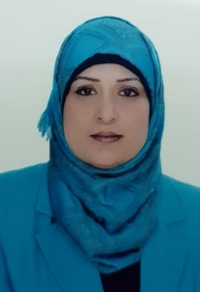
Name: Suhad Mohammed Ali Sadeq.
Scientific Grade: Assistant Professor.

Department:
College of Dentistry, University of Mustansiriyah.
Chairman of the department of ( Pediatric dentistry, Orthodontics, and preventive dentistry(2014-2019).

Educational Background:
* 1992-1993 -----Bachelor's degree in Dental surgery, at University of
Baghdad.
* 2000 -----Master of Science in Orthodontics, at University of Baghdad.
Specialty: Orthodontics.
Interest:
*Orthodontic treatment with different type of orthodontic fixed appliances.
*Treatment of incorrect myofunctional habits
Experience:
* Orthodontic removable appliances, functional and orthopedic appliances.
* Different system of orthodontic fixed appliances.
Memberships:
* Member of Iraqi Dental Association.
* Member of Iraqi Orthodontic Society.
* Member of Arabic Orthodontic Society.
Contact information:
* Mobile: 07901343201
* E-mail: 1) suhad.ortho@yahoo.com
2) dr.suhadmas@uomustansiriyah.edu.iq.

Member of Editorial Board: Mustansiria Dental Journal.
Member of Consultant Board: Journal of Iraqi Orthodontic Society.
*Chairman of scientific Astrology Committee. (2012 - till now).
* Member of scientific committee in the Pediatric, Orthodontics, and preventive dentistry department. (2014- till now).
*Chairman of Pediatric, Orthodontics, and preventive dentistry department.(2014- 2019).

