SAAD KHALID RAHI AlJIZANI

Asst. prof. in physics "Laser & Quantum Optics"

[saadkhskr79@uomustansiriyah.edu.iq](mailto:saadkhskr79@uomustansiriyah.edu.iq) +9647730255188, +9647702550665

IRAQ/ BAGHDAD, 10001 Baghdad

Profile

With over 15 years of teaching experience at Mustansiriyah University in Baghdad, I have developed extensive expertise in physics education. Since 2009, I have been dedicated to instructing undergraduate and graduate students, delivering comprehensive lectures and practical sessions that foster deep understanding and critical thinking. My academic journey is marked by numerous scientific publications in reputable international journals, reflecting my commitment to advancing research in quantum optics. Fluent in Arabic and English, I bring a diverse skill set that includes effective communication, leadership, and advanced analytical abilities, all aimed at contributing to the academic and scientific community.

Education

Bachelor's degree in Physics 1999 - 2004

Mustansiriyah university, Baghdad

Master's degree in Physics 2004 - 2006

Mustansiriyah university, Baghdad

Personal details

Date of birth

December 22, 1979

Place of birth

BAGHDAD / IRAQ

Gender

Male

Nationality

IRAQ

Website scholar.google.com/citations? user=athQGSAAAAAJ&hl=ar

ORCID

orcid.org/my-orcid?orcid=

0000-0001-8631-2918

scopus scopus.com/authid/detail.uri? authorId=57208129002

Ph.D. Physics 2021 - 2024 Mustansiriyah University, Baghdad

PhD in Physics, specializing in lasers and quantum optics

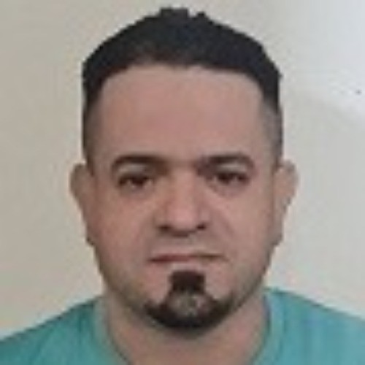

Internships

The National University of Science and

Technology

Nasiriyah, Dhi Qar, Iraq

Nanomaterials Preparation and Patent Writing Workshop

Duration: 28 December 2020 – 29 December 2020

Description:

Participated in a comprehensive workshop on preparing nanomaterials using laser sources.

Conducted hands-on experiments and learned techniques for synthesizing and characterizing nanomaterials.

Attended sessions on writing and obtaining patents in Iraq. Collaborated with peers to develop patent applications and understand the legal framework for intellectual property protection

Mustansiriyah University, Continuing

Education Center

Baghdad, Iraq

Skills

Advanced Physics Knowledge Extensive understanding of quantum optics, laser technology, and nanomaterials.

Research and Analytical Skills Proficient in designing, conducting, and analyzing scientific experiments. Experienced in using data analysis software such as MATLAB and CST.

Scientific Writing and Publications Published numerous research papers in reputable international journals. Skilled in writing and

Scientific Steps to Obtain a Patent Workshop

Date: March 7, 2021

Description:

Attended a workshop focused on the scientific steps necessary to obtain a patent.

Learned about the legal and procedural aspects of patent applications in Iraq.

Gained insights into drafting patent documents and preparing submissions.

Participated in discussions and exercises to apply knowledge in practical

Mustansiriyah University, Continuing

Education Center

Baghdad, Iraq

8. Ionizing Radiations and Protection Methods Workshop

Date: March 3, 2021

Description:

Participated in a workshop on ionizing radiations and methods of protection.

Learned about the sources and effects of ionizing radiation. Studied various protection techniques and safety measures. Engaged in practical sessions on implementing radiation protection protocols.

Mustansiriyah University, College of Science, Continuing Education Center Baghdad, Iraq

9. Polymers Physics and Laser Dyes Lecture

Date: January 15, 2021

Description:

Attended a lecture on the physics of polymers and laser dyes. Explored the effects of laser interactions on polymer materials and laser dyes.

Learned about the applications and implications of laser technologies in material science.

Participated in discussions on recent advancements and research in the field.

Certificates

I have been awarded numerous certificates of appreciation for participating in various scientific conferences, seminars, and discussion panels locally and internationally.

Received more than 10 letters of commendation from Ministers of

Higher Education.

I received over 30 letters of appreciation from university presidents and college deans for outstanding contributions to the academic community and scientific research.

Extracurricular activities

Mustansiriyah University 2010 - Present

Baghdad

Played a key role in organizing annual scientific conferences and symposiums.

preparing research reports and patent applications.

Teaching and Mentoring Over

15 years of experience in teaching physics at the university level.

Ability to explain complex scientific concepts clearly and engagingly. Mentored undergraduate and graduate students in their research projects.

Laboratory Techniques and Safety: Proficient in conducting experiments with laser systems, photonic devices, and nanomaterials. Knowledgeable in radiation safety and implementing protection protocols.

Computational Skills Experienced in computational physics, including simulations and modeling of physical systems. Proficient in using software tools for scientific research and data analysis.

Collaboration and Teamwork Proven ability to work effectively in multidisciplinary research teams. Strong collaboration skills with national and international researchers.

Project Management: Experienced in managing research projects from conception to completion. Skilled in coordinating activities, managing resources, and meeting project deadlines.

Communication and Presentation: Excellent verbal and written communication skills in both Arabic and

Coordinated with national and international speakers, managing schedules and logistics.

Oversaw the publication of conference proceedings and facilitated networking opportunities for attendees.

Outreach and Community Engagement

Various Educational Institutions 2009 - Present

Baghdad

Conducted physics workshops and seminars

Participated in community science fairs and exhibitions, promoting public understanding of physics.

Volunteered as a guest speaker at educational events and career guidance sessions.

Professional Associations Membership

English. Proficient in preparing and delivering scientific presentations and lectures.

Innovation and Problem-Solving Demonstrated ability to develop innovative solutions to complex scientific problems. Skilled in identifying research opportunities and exploring new scientific ideas.

Collaborations with various international

universities and research institutions.

2013 - Present

Languages

Engaged in collaborative research projects with international peers. Participated in exchange programs to share knowledge and expertise.

Fostered partnerships with global research institutions to enhance scientific collaboration.

Mustansiriyah university 2021

Baghdad

Member of the financial and preparatory committee for the second edition of the "Mustansiriyah International Conference for Applied Physics"

Arabic

English

Hobbies

reading travel

Swimming

horseback riding