Curriculum vitae
Name: ALAA FADHIL ALWAN 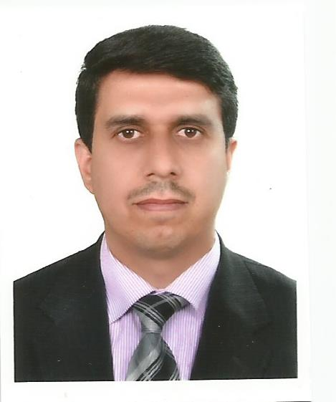
Sex: male
Place & date of birth: IRAQ – DIYALA-Alkhalis / 11 August 1973
Nationality: Iraqi
Marital status: Married, 3 babies
E-mail: ala_sh73@yahoo.com
Languages:
1. Arabic
2. English

Qualifications:
- Fellow of Iraqi board for medical specialization in internal medicine
- Fellow of Iraqi board for medical specialization in adult clinical hematology
- Certificate of competence in lymphoma
- Diploma in lymphoma from Ulm university/ Germany
- M.B.Ch.B from Tikrit University College of medicine.

Employment history:

- February 2015 promotion to consultant in adult clinical hematology
- October 2014 promotion to professor degree in adult clinical hematology
- October 2012 to date : director of the national center of hematology at Almustansiriya university
- May 2009 to October 2014: Assistant professor of clinical hematology / Almustansiriya university/ college of medicine
- May 2009 to February 2015: senior hematologist at the National center of hematology/ Almustansiriya university
- Feb. 2005 to May 2009: Instructor / Tikrit University College of medicine
Department of medicine
- from Oct. 2005 to May 2009: Attending physician /Hematology unit / Baghdad
Teaching hospital
- from 2000-2004 joined the training programme of Iraqi Board in internal
Medicine as senior house officer / Baghdad Teaching Hospital.
- from1999-2000 lecturer at Tikrit University College of Medicine /Department
of medicine
8. from 1997-1999 junior resident / Medical city hospital.

Activities & knowledge:
- Active member of Iraqi Medical Association since 1997 till now
- Active member of European Hematology Association (EHA) since 2008 till now
- Active member of European school of oncology since 2007 till now
- Active member of international society of hematology since 2010 till now
- Regular participant in the educational programs of EHA, ESO, and ASH.
- Interested in clinical Hemato-oncology and bone marrow transplant
- Editor in chief of Iraqi journal of hematology since 2012 till now

Research works:
Published
1. Serum lactate dehydrogenase level in non-Hodgkin’s lymphoma: relationship
to certain features at time of diagnosis. Tikrit Med.J. Vol.13, no.2, 2007, p32-38
2. Serum Lactate Dehydrogenase Level in Acute Leukemias. J. of Baghdad
Medical Faculty, vol. 49, no.4, 2007, p 369-74.
- Acute Transformation in Chronic Myelogenous Leukemias. Tikrit Med. J.
Vol. 13, no.1, 2007, p 12-17.
- acute myeloid leukemia : clinical features and follow-up of 115 Iraqi patients admitted to Baghdad Teaching hospital.Tikrit Med. J.vol 15.no.1.p1-8
- Efficacy of ceftazidime plus amikacin as an initial empirical therapy for adult patients with febrile neutropenia.int j sci tech.jordan.2012 july
- The efficacy of fludarabine, high dose cytosine arabinoside with granulocyte colony stimulating factor (FLAG) protocol as salvage therapy for refractory/relapsed acute leukemias in adult Iraqi patients. Indian Journal of Hematology and Blood Transfusion.February 2013
- Study of Plasma fibrinogen in pregnant women with severe preeclampsia. IOSR Journal of Dental and Medical Sciences.Volume 8, Issue 5 (Jul.- Aug. 2013), PP 55-59
- Outcome of 50 Iraqi patients with acute lymphoblastic leukemia treated by modified German multicenter study group (GMALL) protocol.journal of Almustansiriya medical college.
- Evaluation of the Safety of Imatinib Mesylate in 200 Iraqi Patients with Chronic Myeloid Leukemia in the Chronic Phase: Single-Center Study. Turk J Hematol. 2013; 30(4): 387-393 | DOI: 10.4274/Tjh.2012.0135
- Assessment of the efficacy and safety of intravenous iron sucrose in treatment of adult patients with iron deficiency anemia. community medicine.2013
- Prospective single-center study of chronic myeloid leukemia in chronic phase: switching from branded imatinib to a copy drug and back
More: http://informahealthcare.com/doi/abs/10.3109/10428194.2014.904508
- Efficacy and Tolerance of Fludarabine and Cyclophosphamide (FC) Combination Regimen in advance stage of Chronic Lymphocytic Leukemia. J Med J 2013; December: Vol. 47 (4) http:∕∕dar.ju.edu.jo∕jmj
- Incidence of von Willebrand disease among patients presenting with various bleeding tendency to out-patient clinic of the national center of hematology. Iraqi journal of hematology vol 2 issue1.
- Incidence of hepatitis G virus in patients with hematological malignancies with repeated blood transfusion. IOSR Journal of Applied Chemistry. Volume 4, Issue 1 (Mar. – Apr. 2013), PP 16-18
- Assessment of cytogenetic response after treatment with imatinib mesylate in patients with chronic phase chronic myeloid leukemia. Iraqi journal of hematology.vol.2.issue 1
- Incidence of Epstein Barr Virus infection in newly diagnosed non-Hodgkin lymphoma in the national center of hematology-single center study. Iraqi Journal of Cancer and Medical Genetics. 2014.Volume 7 - Number 1
- Evaluation of Electrolytes in Adult Patients with Acute Leukemia before and after Chemotherapy. J. Baghdad for Sci. Vol.10(2)2013
- Survival of patients with multiple myeloma diagnosed at the national center of hematology in Baghdad. Iraqi Journal of Cancer and Medical Genetics . 2014.Volume 7 - Number 2
- Clinical features and therapeutic outcome of 30 patients diagnosed with primary myelofibrosis at the national center of hematology. J Fac Med Baghdad 2014; Vol.56, No .4
- Assessment of Plasma FXII:C in pregnant women with severe preeclampsia. Mustansiriya Medical Journal Volume 14 Issue 1 June 2015
- DETECTION OF HUMAN HERPESVIRUS 6 IN PATIENT WITH ACUTE MYELOID LEUKEMIA IN BAGHDAD-IRAQ. Int. J. Science Nature, VOL.6 (3) 2015: 484-487
- Assessment of side effects of venesection (phlebotomy) procedure in Iraqi patients presenting with erythrocytosis: single center experience. IJH.2015;vol 4. No.1: pp 61-66
- C- Reactive protein and iron status in Iraqi patients with acute myeloid leukemia before and after treatment. IJH 2015; vol 4.no.1: pp 101-118
- Association of human herpesvirus 6 with lymphoid malignancies in Iraqi patients. IJH 2015; vol 4,no.2 : 18-29
- Inducing of interleukins-10 and 8 by Epistein BarrVirus in chronic lymphocytic leukemia. IJH. Vol 5, issue1 , May 2016
- Types of anemia in patients with rheumatoid arithritis in Sulaymaniyah- Kurdistan region of Iraq . IJH. Vol 5 , issue 1 , May 2016
- Assessment of Biochemical and Molecular Biomarkers for Diagnosis\Prognosis of Chronic Lymphocytic Leukemia in Iraqi Patients. International Journal of Science and Research (IJSR).Volume 5 Issue 6, June 2016
- Estimation of ZAP-70, interleukin 6 nd interleukin 10 levels in sera of Iraqi newly diagnosed CLL . IJH 2016 .vol 5 issue 2

